FRONT END – PART 1
ANIMATIONS AND 3D SPACE

(Values of Transform Property)
1. What values can the ‘transform’ property take? (Multiple options are correct)
a) translate(x,y,z) b) translate(x,y) c) rotate3d(x,y,z,deg)
d) scale(x,y,z) e) scaleX(x)

(Translate Output)
2. There are two divs - outer div(200x200) of brown color, and inner div(100x100) of purple color as shown. If you apply ‘transform: translateY(100px)’ to the inner purple div, what will be the output?



Hint: The Y-axis is inverted in the coordinate
system that CSS uses i.e. +ve Y direction is
downwards, while -ve Y direction is upwards.

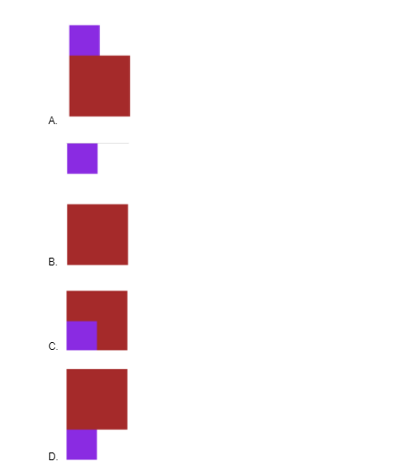
a) A b) B c) C d) D

(Transition Property)
3. Which of the following is false regarding the transition in CSS? (Multiple options are correct)
a) The transition property is used to change the CSS properties of an element over a period of time.
b) The transition property can help control the transition speed of CSS properties.
c) The transition-duration property is used to specify the transition delay or time when the transition begins.
d) The default value for transition-duration is zero.

**********

